Scope of Work
Submitted to Chris Pennell
Manager, Technical Analysis
Utah Division of Air Quality
Title: TRAX Air Quality Observation Project
Project Period: 1 July 2018 - 30 June 2023
Investigators: Daniel Mendoza, Logan Mitchell, John Horel, John Lin
Department of Atmospheric Sciences
University of Utah
1) Project Background

Utah’s Wasatch Front experiences poor air quality episodes during both summer and winter due to its unique weather, topography, and pollutant emissions. During winter, inversions trap unhealthy concentrations of fine particulate matter (PM_{2.5}), while high pressure during summer leads to elevated ozone (O₃) levels. Air quality resources along the Wasatch Front include fixed sites from the Utah Division of Air Quality (UDAQ) and University of Utah (U of U) researchers. Four years ago, we deployed air pollution sensors on a single TRAX light rail cars that traversed the Salt Lake Valley on the Red and Green lines. TRAX air quality data have been available to the public to monitor how air quality varies across the Salt Lake Valley at minute-by-minute scales. Last year we refurbished two trains with suites of particulate and ozone sensors through funding from the Utah State Legislature and UDEQ, as well as installing two fixed sites with identical particulate sensor instrumentation as on the two light rail trains for calibration and validation purposes. A companion proposal has been submitted for a third train sensor suite on the TRAX light rail blue line, which will cover portions of the southeastern portion of the Salt Lake Valley not observed by the existing trains.

A brief summary of last years’ installation of air quality sensors on the TRAX train through UDEQ funding is provided below:

Year 1 TRAX Observation Project:

Beginning in Fall 2018 we transitioned the TRAX air quality observation project from the pilot phase to the operational phase. This was done by the following actions:

- Replaced and repair aging sensors (November 2018)
- Expanded from one TRAX light rain train to two light rail trains.
3) Maintaining and servicing all sensors at high standards. We have maintained the measurements at a higher standard than was possible
before state funding became available, including newer sensors, a daily spreadsheet of any potential measurement issues (e.g., fog). This includes monthly inspections of all instruments by a lab technician and making sure the 2B ozone sensors are calibrated and retain FEM status.
4) We have started a plan of action for applying quality control (QC) measures needed for the data set. More detailed QC will be conducted next year and the QC’d data set will be furnished to UDEQ as well as permanently archived at the publically accessible and state-of-the art University of Utah repository called the HIVE (https://hive.utah.edu/about)
5) Public dissemination of the TRAX air quality information including online real-time
visualization of TRAX air quality measurements and a publicly-accessible archive
of TRAX real-time air quality data for download for those looking for data to put on
websites, etc.

More details on the previous year of the TRAX project is found in the final report from last year. The TRAX project is unique, particularly in the USA; only a few mobile urban observation networks leveraging public transit currently exist worldwide: Zurich, Switzerland (Hasenfratz et al., 2015); Karlsruhe, Germany (Hagemann et al., 2014); Oslo, Norway (Castell et al., 2015); and Perugia, Italy (Castellini et al., 2014). It has been shown that public transit based monitoring can be used to create high-resolution maps of air pollution across urban areas (Hasenfratz et al., 2015). The TRAX air quality monitoring effort is the first to utilize public transit for urban observations of trace species in North America.
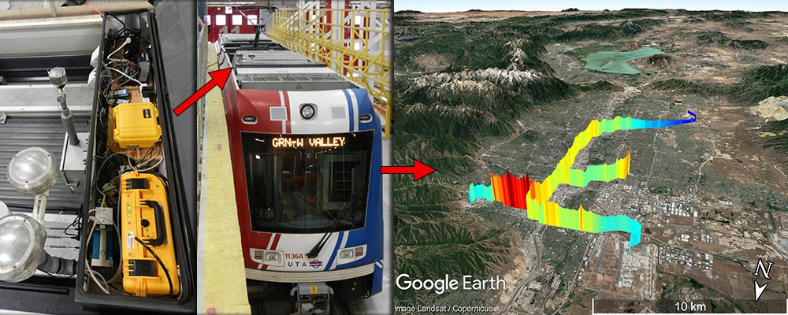
Figure 1. Schematic showing the TRAX instrumentation box, a TRAX train, and a Google Earth plot of the data.

As described by Mitchell et al. (2018), the Utah Transit Authority (UTA) “TRAX light rail train network consists of over 145 electric trains servicing three lines (Red, Green, and Blue) along 94 km of rail track that provide coverage across the SLV (Figure 1). Urbanization along the rail lines varies from dense urban downtown regions to suburban and rural settings, and the train travels on and off major roadways. TRAX operates an older model of rail car on the Blue line, so our data are almost exclusively from the Red and Green lines. Along the Red and Green lines there are 25 and 18 passenger stops, which take 60 and 46 minutes, respectively, to complete a transect on each line. In addition to the spatial coverage, the Red line also provides a 225 m pseudo-vertical profile from the valley floor (1,285 m) to the surrounding mountain foothills (1,510 m). Each TRAX train car covers 18-24 transects when operating for a full day (approximately 18 hours from 5 AM to midnight). During the period December 2014 – April 2017, the trains have been deployed 760 days comprising 10,300 transects (averaging 14 transects a day and deployed 61% of days, or ~4 days a week). When the trains were not in operation, they were often parked outside and therefore became periodic stationary observation sites that provided additional observations.”

TRAX is a unique platform available to capture spatial variations in ozone and PM_{2.5} when the light rail cars are operating. The first year of the successful TRAX project supported by UDEQ needs to be continued for a second year to 1) continue the ongoing high quality collection, calibration, and maintenance of the TRAX air quality instrumentation and communication and logging software onboard the light rail trains, 2) to continue to validate, calibrate, and maintain the instrumentation, 3) to apply stringent quality control (QC) measures to the data set and 4) to support the archival and dissemination of the information to air quality decision makers, the public, and researchers.

2) Deliverables

- The specific deliverables that will be provided during the Year 1 (July 1, 2018 - June 30, 2019) project period are as follows:

- Installation of new calibrated PM_{2.5} and ozone sensors on the two TRAX light rail trains.
- Deployment of fixed PM_{2.5} sensors to evaluate the TRAX based measurements against UDAQ measurements at the Hawthorne site.
- Online real-time visualization of TRAX air quality measurements.
- Publicly-accessible archive of TRAX air quality data for download.
- Quality control and rigorous validation of TRAX PM_{2.5} data against UDAQ Hawthorne PM_{2.5} measurements.
- Copy of the quality-controlled data archive for archival with UDAQ.
- Quarterly reports that summarize the status and progress of all aspects of this project.
- Annual report that includes reports on data usage, availability, and validation.

- The specific deliverables that will be provided during the Year 2 (July 1, 2019 - June 30, 2020) project period are as follows:

- Development of a higher quality quality-controlled data set with QA/QC flags that will be archived each year for public access in the University of Utah HIVE archive.
- Extended validation of TRAX PM_{2.5} data against UDAQ Hawthorne and Along-track location PM_{2.5} measurements. Focus on the new installation on the Blue Line.
- Continuing to calibrate and maintain all sensors at a high level (includes calibrations, repairs, inspections) monthly flow and sensor audits during inspections).
- Backup ozone sensor and PM_{2.5} sensor calibrated and on call to replace any sensors in need of manufacturer repairs.
- Continued support of online real-time visualization of TRAX air quality measurements and a publicly-accessible near real-time archive of TRAX air quality data for immediate download.
- Copy of the quality-controlled data archive for archival with UDAQ.
- Quarterly reports that summarize the status and progress of all aspects of this project. Presentation of the results at the annual UDAQ Science for Solutions Conference.

- The specific deliverables that will be provided during the Year 3 (July 1, 2020 - June 30, 2021) project period are as follows:

- Completion of year 1-2 quality quality-controlled data set with QA/QC flags and ongoing inclusion of data for all study years.
- Analysis of the specific air quality data collected during years 1 and 2 and presentation at the annual Science for Solutions conference.
- Continuing to calibrate and maintain all sensors at a high level (includes calibrations, repairs, inspections) monthly flow and sensor audits during inspections).
- Continued support of online real-time visualization of TRAX air quality measurements and a publicly-accessible near real-time archive of TRAX air quality data for immediate download.
- Two-year calibration of PM_{2.5} and ozone sensors per manufacturer’s standards.
- Copy of the quality-controlled data archive for archival with UDAQ.
- Quarterly reports that summarize the status and progress of all aspects of this project.

- The specific deliverables that will be provided during the Year 4 (July 1, 2021 - June 30, 2022) project period are as follows:

- Ongoing archival and QA/QC of all collected data.
- Analysis of the specific air quality data collected during years 1-3 and presentation at the annual Science for Solutions conference.
- Continuing to calibrate and maintain all sensors at a high level (includes calibrations, repairs, inspections) monthly flow and sensor audits during inspections).
- Presentation to UDAQ and Utah State Legislature about data collected and studies performed using this data. Request feedback from stakeholders regarding potential uses of this data and tools.
- Copy of the quality-controlled data archive for archival with UDAQ.
- Quarterly reports that summarize the status and progress of all aspects of this project.

- The specific deliverables that will be provided during the Year 5 (July 1, 2022 - June 30, 2023) project period are as follows:

- Ongoing archival and QA/QC of all collected data. Years 1-4 all archived at the University of Utah HIVE repository.
- Analysis of the specific air quality data collected during years 1-4 and presentation at the annual Science for Solutions conference.
- Continuing to calibrate and maintain all sensors at a high level (includes calibrations, repairs, inspections) monthly flow and sensor audits during inspections).
- Two-year calibration of PM_{2.5} and ozone sensors per manufacturer’s standards.
- Copy of the quality-controlled data archive for archival with UDAQ.
- Quarterly reports that summarize the status and progress of all aspects of this project.
- Final report that includes reports on data usage, availability, and validation.

More details on the various aspects of the TRAX deliverables during the project are provided below:

3) Installation of Air Quality Instrumentation on TRAX

The following instrumentation has been proven to be accurate and robust on the TRAX train (Mitchell et al., 2018). The instrumentation currently deployed on TRAX has been heavily used and needs to be replaced. Two TRAX trains (numbered 1136 and 1104) will be outfitted with the new sensors to measure air quality. Electrified trains are an ideal platform for air sampling because they have zero direct emissions and run continuously throughout the day whenever they are operating. The trains have electric circuitry on their roofs in steel weatherproof boxes, and our instruments were installed in one of the spare boxes (dimensions 1.5 m x 0.5 m x 0.5 m). The sample inlets extended 0.5 m above the top of the train through a pipe protruding from the metal box topped with a vent cover and were 4 m above ground level. AC power was provided with a connection into the main power through an inverter. Two generic computer fans provided cooling for the instruments in the box in the summer. Table 1 lists the equipment that will be installed on both of the TRAX trains, as well as the instrumentation sampling frequency and their measurement accuracy.

Table 1
Measurement equipment for PM_{2.5} and Ozone to be purchased and deployed on TRAX train cars.
Instrument | Species | Sampling rate | Measurement uncertainty
Met One Instruments ES-642 Remote Dust Monitor | PM_{2.5} | 1 sec. | 1 µg m⁻³
2B Technologies Model 205 Ozone Monitor | O₃ | 2 sec. | 2%
4) Development of QA/QC Data Archive

This past year, detailed records of pertinent daily data regarding instrumentation on the TRAX trains has been being recorded in an online log for TRAX on our operational google doc spreadsheets. Undergraduate students are responsible for filling out several daily spreadsheets. In addition to frequent checks of instruments, calibration of sensors, flow checks, we also keep careful track of weather conditions such as high winds, high humidity, wildfire smoke, etc. that complicate air quality measurements. Undergrad technical assistants will continue this work as ongoing this year.

We have held several planning meetings discussing extensive plans for QA/QC for the second year of the TRAX project. We will include flags in the archived QA/QC data set for each potential issue with the data as well as recommendations for the highest quality data (what data to exclude from analysis for various applications using the QA/QC flags). The following factors have been identified at this stage that will be included in this year’s implementation of the QA/QC process:

- Low flow errors (PM and ozone)
- Other instrument errors (clogged filter, lamp failure on ozone, nephelometer failure on PM)
- RH > 85% (almost always reads significantly high for PM)
- RH between 70 and 85% (some minor RH impacts on PM)
- Very hot or very cold temperatures (sensors could be impacted, have not really looked at)
- Train inside versus outside

As we implement various tests and calibration/validation of the TRAX data sets in comparison to UDEQ Hawethorne data, etc, additional data QA/QC flags will likely be implemented. A graduate student supported outside of this project will work with Alex Jacques, Logan Mitchell, and Ben Fasoli to apply the QA/QC to the data set. There has been discussion of multiple levels of QC, with the level 0 being native format, level 2 QC flags applied, and level 3 the final QC calibrated data set in NetCDF or CSV format.

Once the detailed QA/QC has been applied to the current TRAX data set supported on two light rail trains that began in winter 2018, the data set and all flags and documentation will be packaged up for use by UDEQ, the public, and researchers.

The current plans are to archive the QA/QC dataset annually at the University of Utah HIVE archive, a “publicly-accessible repository for research data generated by University of Utah researchers, students, and staff.” https://hive.utah.edu/. It is likely that new “versions” of the archived data set may become available as better QA/QC approaches are applied.

5) Data Validation, Calibration, and Quality Control Procedures

A key new component of this study will be establishing careful data validation, calibration, and quality control procedures. For data validation of PM_{2.5} starting with this project, a fixed tripod with an ES-642 PM_{2.5} sensor will be placed at the UDAQ Hawthorne Elementary School site, to provide a baseline comparison of the measurements of the ES-642 Nephelometer to the UDAQ Federal Equivalent Method (FEM) measurements. A second fixed tripod with ES-642 sensors will be placed along the TRAX lines at a central location. Regular calibration, comparison, and validation of the TRAX sensors with the fixed sensors will be carried out. This will allow for careful quantification of any errors and biases in the TRAX measurements relative to UDAQ Hawthorne PM_{2.5} measurements, as well as to ascertain that instrument drift, fog, smoke, and other environmental factors that could potentially impact the TRAX measurements are carefully documented and quantified. The ozone instruments will be calibrated bi-monthly using a calibration unit recently obtained through a University instrumentation grant by the University of Utah Atmospheric Trace gas and Air Quality (U-ATAQ) laboratory (https://air.utah.edu/).
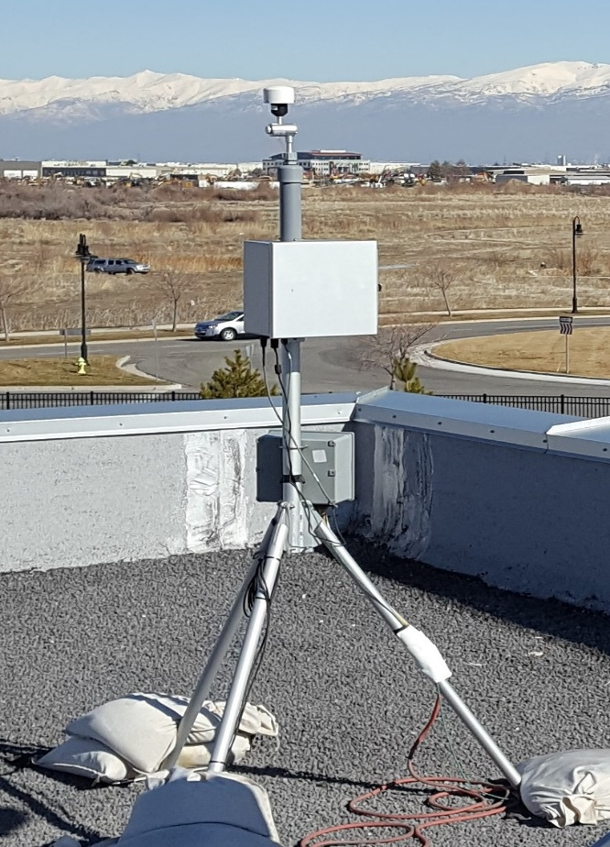
Figure 2. Example validation PM_{2.5} sensor with a tripod.

The part-time technicians working on this project will also work to complete the quality control for the data both going forward and for the previous 2014-2018 data record.

6) Extended Validation of TRAX PM_{2.5} data against UDAQ Measurements

Additional data validation and calibration on the TRAX data will be conducted. A preliminary validation of the TRAX data was conducted in Spring 2019 and presented at the Science for Solutions conference in Logan Utah By Dr. Logan Mitchell on March 27, 2019. As shown in Figure 3, there was remarkable agreement between both TRAX train PM_{2.5} data and the fixed site PM_{2.5} data along the tracks at the times when the train goes by. Extended data validation will be conducted for the entire UDEQ-funded TRAX data set beginning between November 2018 – August 2019. For the entire period of record of the UDEQ-funded TRAX collection on the two trains beginning in November 2018, validation data for PM_{2.5} has been collected at a fixed tripod with an ES-642 PM_{2.5} sensor at the UDAQ Hawthorne Elementary School site (to provide a baseline comparison of the measurements of the ES-642 Nephelometer to the UDAQ Federal Equivalent Method (FEM) measurements) as well as at a second fixed tripod with ES-642 sensors at approximately 2700 S in the Salt Lake Valley (Figure 4).
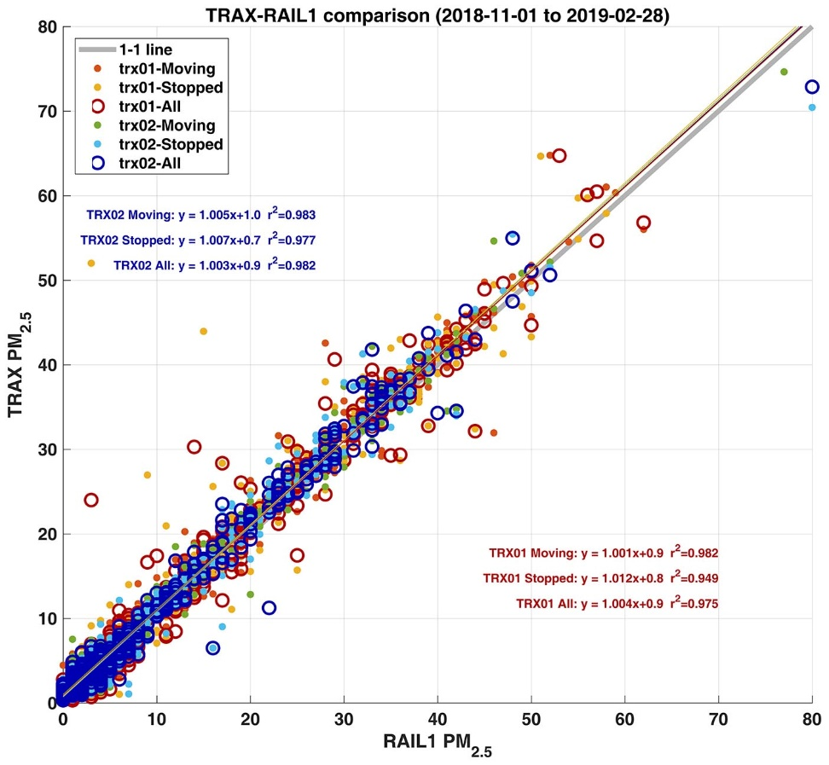
Figure 3: Regression lines comparing the fixed RAIL1 site (see Fig. 1) with the TRAX1 and TRAX2 trains as they move past the fixed site location for the period 1 November 2018 – 28 February 2019
Figure 4: Photos of the currently-deployed new fixed validation sites located along the tracks near 1800 S (RAIL1; left) and co-located with Utah Division of Air Quality monitors at Hawthorne Elementary (QHW; right). These sensors will remain at this site through winter 2019 to give additional validation data and to validate the new 3rd sensor being deployed on the TRAX Blue Line in Fall 2019.

Regular calibration, comparison, and validation of the TRAX sensors with the fixed sensors will be carried out for maintenance, QA/QC and validation purposes. These two fixed sites will remain operational through the rest of 2019 and have been extended to provide additional validation data during summertime wildfire smoke episodes in the summer of 2019 as well as wintertime inversions (because the last winter did not have extended cold-air pools). In addition, the extended validation data will be important to validate the new installation this summer/fall on the TRAX Blue Line (the third sensor suites on the train that is being submitted as a separate single one-time grant to UDEQ). This validation data will allow for careful quantification of any errors and biases in the TRAX measurements relative to UDAQ Hawthorne PM_{2.5} measurements, as well as to ascertain that instrument drift, fog, smoke, and other environmental factors that could potentially impact the TRAX measurements are carefully documented and quantified.

7) Instrumentation Inspections, Maintenance, Calibration, and Repairs

All TRAX sensor suites require monthly inspections, as well as technician visits on an as-needed bases when equipment failures occur, which are identified through a series of manual and automated checks. A technician also keeps careful logs of all inspection, maintenance, calibration and repair data online. The ongoing maintenance and calibration activities include:
- Calibration of the ozone instruments will be calibrated bi-monthly using a calibration unit recently obtained through a University instrumentation grant by the University of Utah Atmospheric Trace gas and Air Quality (U-ATAQ) laboratory (https://air.utah.edu/). This year we will also purchase an additional ozone sensor so that there is always an extra one to replace existing ones that need repair, decreasing potential data outages.
- Sending back all instruments periodically for factory calibration.
- Monthly flow rate audits.
- Ordering and replacing pumps, lamps, hoses or other parts as needed.
- Sending sensors back to manufacturer for needed repairs.

8) Online Dissemination and Real-Time Data Access

A key deliverable of the TRAX data system will continue to be supporting real-time and archived data available for the public, UDAQ, and other scientists. Part-time technician time will be dedicated to keeping the instruments in working order on both trains at all times, assisting with the fixed calibration sites, and developing the data archive and public access web interfaces. The air quality observations will continue to be transmitted to U of U servers via cellular communications every 5 minutes from onboard dataloggers. The data will then then archived for real-time display and data access on Network File System (NFS) mounted servers at the Center for High Performance Computing (CHPC) at the U of U.
The near-real time air quality data from this project will continue to be made available through the following publicly-accessible pathways:

- Real-time webpage display of air quality data for forecasting and decision-making
- Download page to access the entire dataset record or subset of that record

9) Performance Measures, Quarterly and End of Project Reporting

The performance metrics will focus on the effectiveness of providing the TRAX air quality data set to UDAQ, the public, state government, and scientific community, as well as the quality (calibration and maintenance of instruments) and dependability (no outages) of the data provided. The various performance measures will be summarized in a detailed final report that will be submitted to the Utah Division of Air Quality (UDAQ) that includes:
- Report on the usage of TRAX data for health, air quality or meteorological research, government forecasting, and public awareness.
- Report on the data availability (in percent), with a goal to have as few data outages as possible.
- Calibration metrics of TRAX PM_{2.5} and ozone data as compared to the UDAQ Hawthorne Elementary monitoring site.
In addition to the final report, we will provide quarterly reports throughout the period from July 2018 to June 2023 that summarize the status of all aspects of this project.
10) Budget and Budget Justification

Fringe Benefits
The fringe benefit rate for full-time faculty/staff is calculated at 37%.
Indirect Costs
University of Utah indirect costs are calculated at a rate of 10.0% of a Modified Total Direct Cost (MTDC).

- Year 1: (07/01/2018 – 06/30/2019)

Personnel Costs: Management | $10,214
Personnel Costs: Technician(s) | $18,040
Fringe Benefits (37%) | $10,454
Instrumentation systems (Excluded from Indirect Costs) | $39,200
Lab/technical supplies, and repairs/maintenance | $3,016
Other expenses (cellular modem fees, truck rental, etc.) | $2,640
Total Direct Costs | $83,564
Indirect Costs | $4,436
Total Costs | $88,000

Personnel
Salary support (1 cal. mos. each) for Research Assistant Professors Mitchell and Crosman. Also support for 3 technicians (5 cal. mos. total) to assist with instrument installation and maintenance as well as quality control, calibration, validation, archival, and public dissemination of the data obtained.

Replacement Instrumentation Systems total: $39,200
New systems for PM_{2.5} and O₃ on both TRAX light rail trains as well as 2 fixed PM_{2.5} stations at UDAQ Hawthorne Elementary School site as well as a central location along the train tracks.

Communication, Supplies, and Other Miscellaneous total: $5,656
Monthly cellular modem fees, power inverter, truck rental, miscellaneous cables, tripod and tripod parts, tools, filters, hoses, instrument repairs and maintenance

- Year 2: (07/01/2019 – 06/30/2020)

Personnel Costs: Management and science and QC | $28,028
Personnel Costs: Technician(s) | $18,000
Fringe Benefits (37%) | $17,030
Instrumentation systems (Excluded from Indirect Costs) | $9,000
Lab/technical supplies, and repairs/maintenance | $1,120
Other expenses (cellular modem fees, truck rental, etc.) | $2,640
Sensor system repairs/calibration | $3,000
Publication page charges | $2,000
Total Direct Costs | $80,818
Indirect Costs | $7,182
Total Costs | $88,000

PERSONNEL

Salary support for Research Assistant Professors Mitchell and Mendoza. Also support for staff scientist Ben Fasoli and postdoctoral researcher Alex Jacques who will be leading the QA/QC of the TRAX data for archival. Also support for 2 technicians (5 cal. mos. total) to assist with instrument maintenance as well as quality control, calibration, validation, archival, and public dissemination of the data obtained.

REPLACEMENT INSTRUMENTATION SYSTEMS total: $9,000

New systems O₃ to be used as a “backup” system when one of the dedicated systems fails and needs to be sent back to manufacturer for repairs.

PUBLICATION PAGE CHARGES total: $2,000

A journal paper describing the operational TRAX system installed since November 2018 will be written.

COMMUNICATION, SUPPLIES, REPAIRS, CALIBRATION, MISC total: $6,760

Monthly cellular modem fees, power inverter, truck rental, miscellaneous cables, tripod and tripod parts, tools, filters, hoses, instrument repairs and maintenance.

- Year 3: (07/01/2020 – 06/30/2021)

Personnel Costs: Management and science and QC | $31,979
Personnel Costs: Technician(s) | $19,000
Fringe Benefits (37%) | $18,862
Lab/technical supplies and repairs/maintenance/manufacturer calibration | $5,519
Other expenses (cellular modem fees, truck rental, etc.) | $2,640
Publication page charges | $2,000
Total Direct Costs | $80,000
Indirect Costs | $8,000
Total Costs | $88,000

PERSONNEL

Salary support for Research Assistant Professors Mitchell and Mendoza who will be leading the data analysis for the project. Also support for staff scientist Ben Fasoli and postdoctoral researcher Alex Jacques who will be leading the QA/QC of the TRAX data for archival. Also support for 2 technicians (5 cal. mos. total) to assist with instrument maintenance as well as quality control, calibration, validation, archival, and public dissemination of the data obtained.

PUBLICATION PAGE CHARGES total: $2,000

A journal paper describing the operational TRAX system installed since November 2018 will be written.

COMMUNICATION, SUPPLIES, REPAIRS, CALIBRATION, MISC total: $8,159

Monthly cellular modem fees, power inverter, truck rental, miscellaneous cables, tripod and tripod parts, tools, filters, hoses, instrument repairs and maintenance. Also repairs and yearly factory calibration by the respective instrument manufactures.

- Year 4: (07/01/2021 – 06/30/2022)

Personnel Costs: Management and science and QC | $29,138
Personnel Costs: Technician(s) | $19,000
Fringe Benefits (37%) | $17,811
Lab/technical supplies and repairs/maintenance/manufacturer calibration | $9,412
Other expenses (cellular modem fees, truck rental, etc.) | $2,640
Publication page charges | $2,000
Total Direct Costs | $80,000
Indirect Costs | $8,000
Total Costs | $88,000

PERSONNEL

Salary support for Research Assistant Professors Mitchell and Mendoza who will be leading the data analysis for the project. Also support for staff scientist Ben Fasoli and postdoctoral researcher Alex Jacques who will be leading the QA/QC of the TRAX data for archival. Also support for 2 technicians (5 cal. mos. total) to assist with instrument maintenance as well as quality control, calibration, validation, archival, and public dissemination of the data obtained.

PUBLICATION PAGE CHARGES total: $2,000

A journal paper describing the operational TRAX system installed since November 2018 will be written.

COMMUNICATION, SUPPLIES, REPAIRS, CALIBRATION, MISC total: $12,051

Monthly cellular modem fees, power inverter, truck rental, miscellaneous cables, tripod and tripod parts, tools, filters, hoses, instrument repairs and maintenance. Also repairs and yearly factory calibration by the respective instrument manufactures. This year more funds will be dedicated to instrument calibration and repairs as all sensors will be sent back to the manufacturers to make sure the project data is of the highest quality possible.

- Year 5: (07/01/2022 – 06/30/2023)

Personnel Costs: Management and science and QC | $29,942
Personnel Costs: Technician(s) | $19,000
Fringe Benefits (37%) | $18,109
Travel (domestic) | $2,500
Lab/technical supplies and repairs/maintenance/manufacturer calibration | $5,809
Other expenses (cellular modem fees, truck rental, etc.) | $2,640
Publication page charges | $2,000
Total Direct Costs | $80,000
Indirect Costs | $8,000
Total Costs | $88,000

PERSONNEL

Salary support for Research Assistant Professors Mitchell and Mendoza who will be leading the data analysis for the project. Also support for staff scientist Ben Fasoli and postdoctoral researcher Alex Jacques who will be leading the QA/QC of the TRAX data for archival. Also support for 2 technicians (5 cal. mos. total) to assist with instrument maintenance as well as quality control, calibration, validation, archival, and public dissemination of the data obtained.

PUBLICATION PAGE CHARGES total: $2,000

A journal paper describing the operational TRAX system installed since November 2018 will be written.

COMMUNICATION, SUPPLIES, REPAIRS, CALIBRATION, MISC total: $8,449

Monthly cellular modem fees, power inverter, truck rental, miscellaneous cables, tripod and tripod parts, tools, filters, hoses, instrument repairs and maintenance. Also repairs and yearly factory calibration by the respective instrument manufactures.

TRAVEL – DOMESTIC Total: $2,500
Travel funds for the final year of TRAX project are included so that one of the scientists involved can present the results of the project at a large conference such as the American Geophysical Union (AGU).

AGU Meeting:
 | 1 trip x 1 persion @ $480 airfare: | $480
 | Ground transportation: | $165
 | 6 nights hotel @ $160/night: | $960
 | 5 days per diem @ $69/day: | $345
 | Conference registration | $550
 | Total | $2600

11) References

Castell, N., Kobernus, M., Liu, H.-Y., Schneider, P., Lahoz, W., Berre, A. J., & Noll, J. (2015). Mobile technologies and services for environmental monitoring: The Citi-Sense-MOB approach. Urban Climate, 14, Part 3, 370–382. https://doi.org/10.1016/j.uclim.2014.08.002
Castellini, S., Moroni, B., & Cappelletti, D. (2014). PMetro: Measurement of urban aerosols on a mobile platform. Measurement, 49, 99–106. https://doi.org/10.1016/j.measurement.2013.11.045
Hagemann, R., Corsmeier, U., Kottmeier, C., Rinke, R., Wieser, A., & Vogel, B. (2014). Spatial variability of particle number concentrations and NOx in the Karlsruhe (Germany) area obtained with the mobile laboratory ‘AERO-TRAM.’ Atmospheric Environment, 94, 341–352. https://doi.org/10.1016/j.atmosenv.2014.05.051
Hasenfratz, D., Saukh, O., Walser, C., Hueglin, C., Fierz, M., Arn, T., et al. (2015). Deriving high-resolution urban air pollution maps using mobile sensor nodes. Pervasive and Mobile Computing, 16, Part B, 268–285. https://doi.org/10.1016/j.pmcj.2014.11.008
Mitchell, L. E., Crosman, E. T., Jacques, A. A., Fasoli, B., Leclair-Marzolf, L., Horel, J., et al. (2018). Monitoring of greenhouse gases and pollutants across an urban area using a light-rail public transit platform. Atmospheric Environment. https://doi.org/10.1016/j.atmosenv.2018.05.044

